Project Proposal

Project subject: Family/Household budget and expenses.

Project team members: Pham Thanh Tung and Sabalin Larisa.

Trello: Java 3 Project Team Larisa_Tung

Github: <https://github.com/loritta/Family-Household-budget-and-expenses..git>

Or

<https://github.com/tpham20908/FamilyBudgetExpenses.git>

Description: The project will have the purpose of collecting the information from the user on the expenses and the income at a given moment.

Initially a login/signup window will be promoted that will further lead to a window of operation choice (add expense, add income and go to reports).

For now the budget will be based on monthly statistics, but an option of manually entering it will be given for each individual (not sure if we will have time to add this part until Wednesday). The total household budget will be calculated based on individual budgets.

An option of seeing the reports based on the data will be given. For now it will be a general expense vs budget per month report. Further, more features can be added.

An option of saving to a pdf file a report will be given.

## List of technologies, libraries, components used (bullet points):

* JAVA, JDBC, Swing
* MySQL, Gearhost
* Git, github
* Trello

## Database structure - screenshot or hand drawing (UML diagrams with relations):

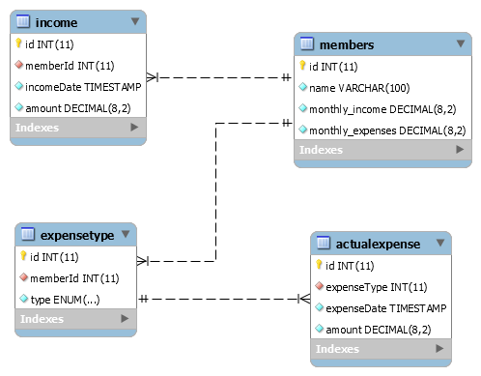

## Screenshots of all the meaningful windows you're planning in your project 3-5 of them:

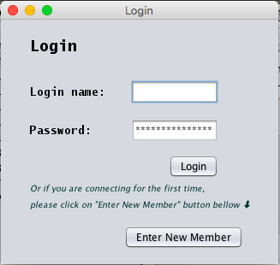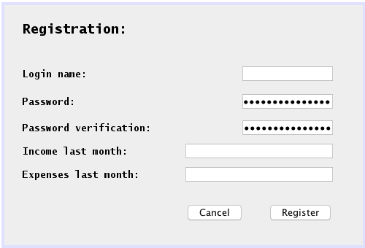

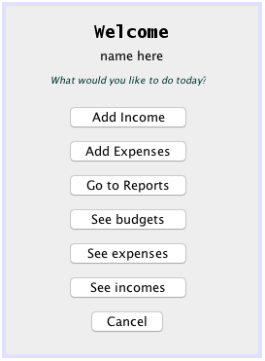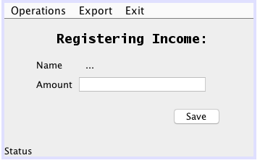

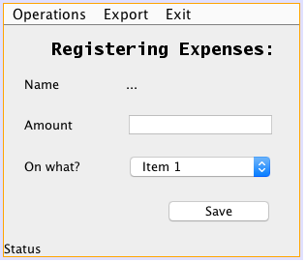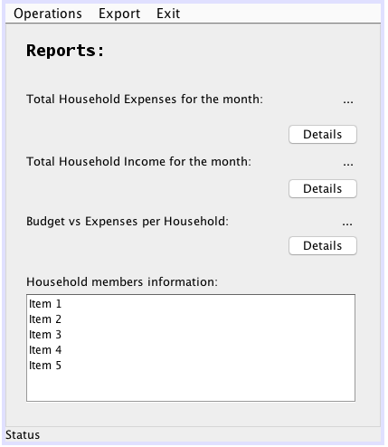

All the SeePages will have this design--- to work it a bit more:

